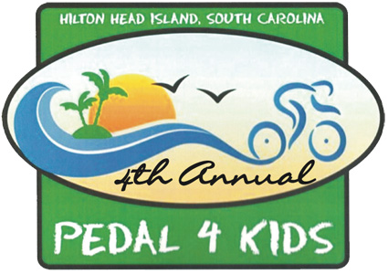

BOYS & GIRLS CLUB OF HILTON HEAD
PEDAL 4 KIDS-DONATION FORM

Name _________________________________________________________________________

Address _________________________________________________________________________

City _______________________________________ State _______________ Zip ______

E-Mail ____________________________________ Phone _________________________

Donation to support the Boys & Girls Club of Hilton Head $ ____________

Support-A-Child for One Year @ $365.00 $_____________

TOTAL AMOUNT ENCLOSED $_____________

Form of Payment ( ) Check: Payable to: Boys & Girls Club of Hilton Head

Credit Card ( ) Visa ( ) MC ( ) AMEX ( ) ACTIVE.COM

Credit Card No _____________________________________________________________________

Exp Date __________________________ Security Code _______________________

Name on Card (Please Print)______________________________________________

Signature______________________________________________________________

Boys and Girls Club of Hilton Head
151 Gumtree Road
PO Box 22267
Hilton Head Island SC 29925
843 689-3646 • www.bgchhi.org

